МИНИСТЕРСТВО НАУКИ И ВЫСШЕГО ОБРАЗОВАНИЯ РОССИЙСКОЙ ФЕДЕРАЦИИ

Федеральное государственное автономное образовательное учреждение высшего образования

«САНКТ-ПЕТЕРБУРГСКИЙ ГОСУДАРСТВЕННЫЙ УНИВЕРСИТЕТ   
АЭРОКОСМИЧЕСКОГО ПРИБОРОСТРОЕНИЯ»

КАФЕДРА 41

ПРАКТИЧЕСКАЯ РАБОТА   
ЗАЩИЩЕНА С ОЦЕНКОЙ

РУКОВОДИТЕЛЬ

|  |  |  |  |  |
| --- | --- | --- | --- | --- |
| ассистент |  |  |  | М.В. Загураева |
| должность, уч. степень, звание |  | подпись, дата |  | инициалы, фамилия |
|  |  |  |  |  |

|  |
| --- |
| ПРАКТИЧЕСКАЯ РАБОТА № 4  РЕАЛИЗАЦИЯ ПРОГРАММНОГО ПРОДУКТА НА ТЕМУ ВИКТОРИНА |
|  |
| по дисциплине: ПРОГРАММНАЯ ИНЖЕНЕРИЯ |
|  |
|  |

|  |  |  |  |  |  |  |  |  |
| --- | --- | --- | --- | --- | --- | --- | --- | --- |
| РАБОТУ ВЫПОЛНИЛИ  СТУДЕНТЫ ГР. № | 8027 |  | 04.04.2023 |  | |  | | --- | | Д.А. Григорьева | | З.Ю. Лебедев | | Э.В. Пекарская | |
|  |  |  | подпись, дата |  | инициалы, фамилия |

Санкт-Петербург 2023

**Цель работы:** программная реализация веб-приложения для проведения викторины.

**Ход работы**

Разработка веб-приложения осуществлялось в среде WordPress, при помощи плагинов (редактора Elementor и составителя викторин QSM).

На рисунках 1-5 представлены разработанные страницы веб-приложения. В приложении А представлен фрагмент HTML-кода главной страницы с комментариями. В приложении Б представлен CSS-код для настройки стиля плагина QSM.

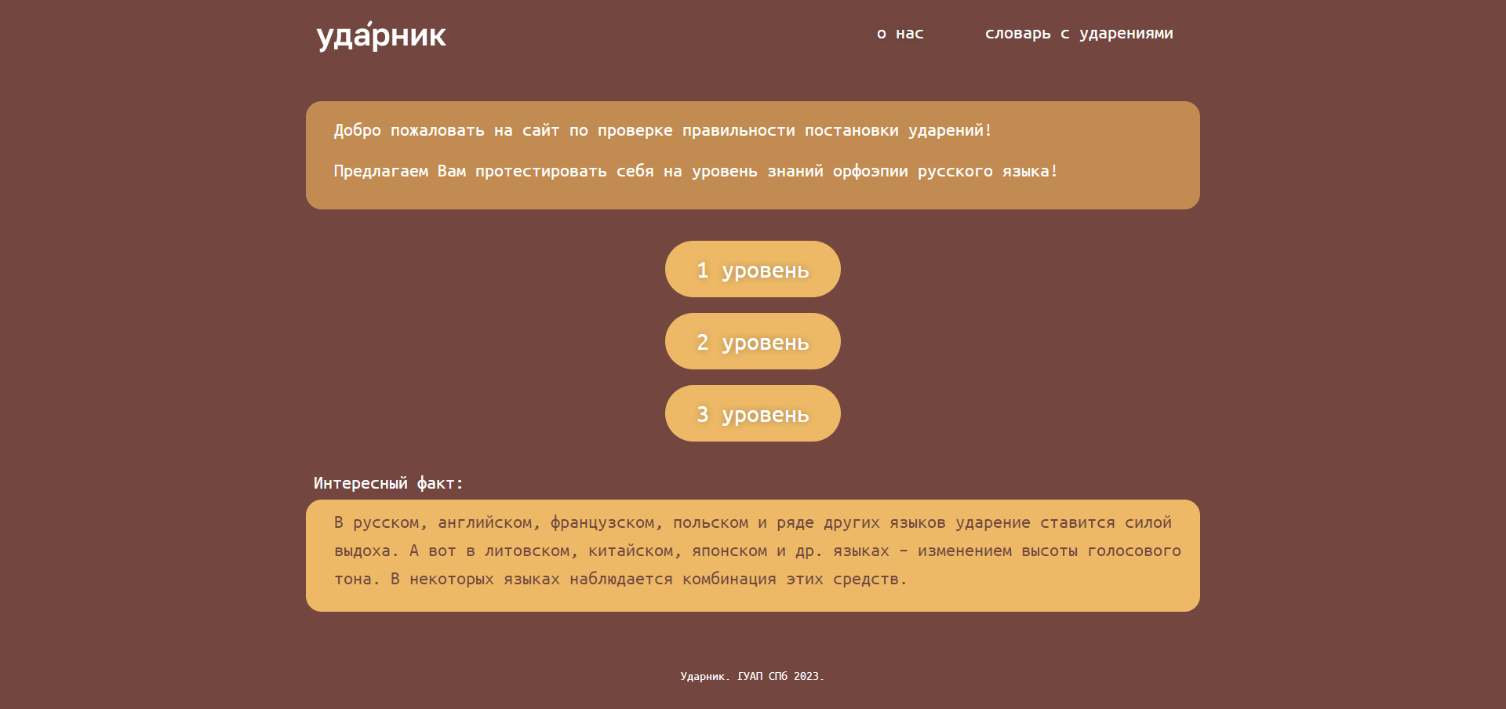

Рисунок 1 – Главная страница веб-приложения

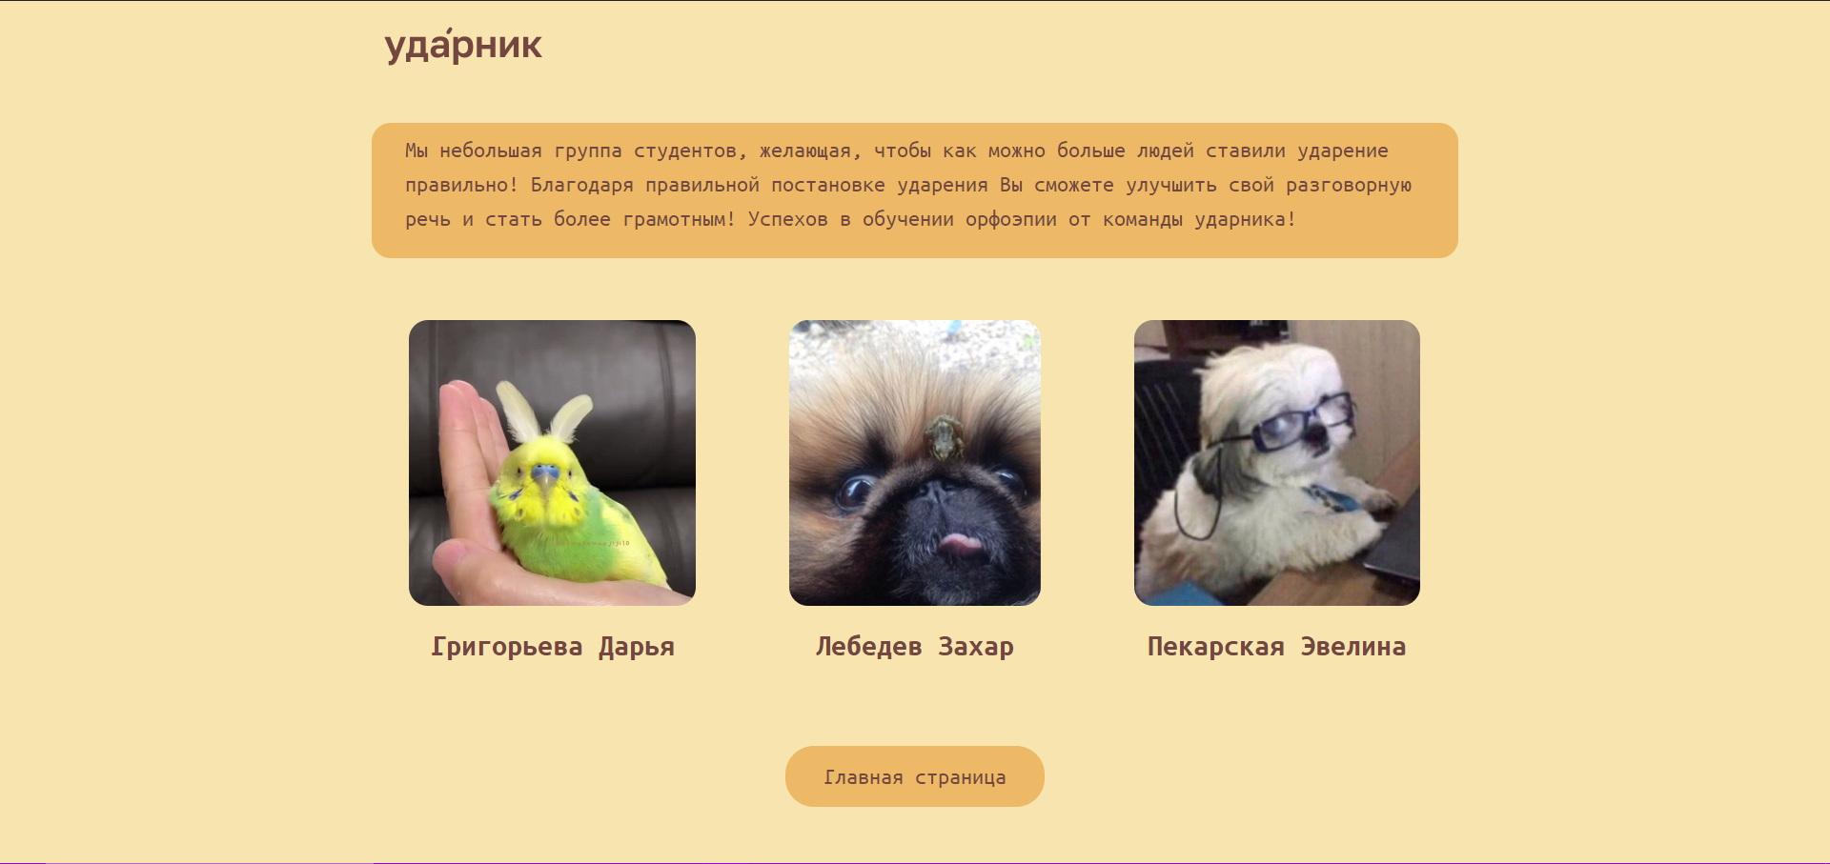

Рисунок 2 – Страница раздела «о нас»

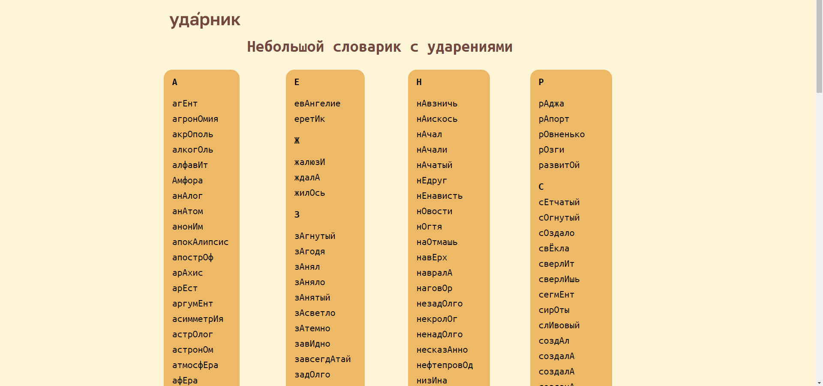

Рисунок 3 – Страница раздела «словарь с ударениями»

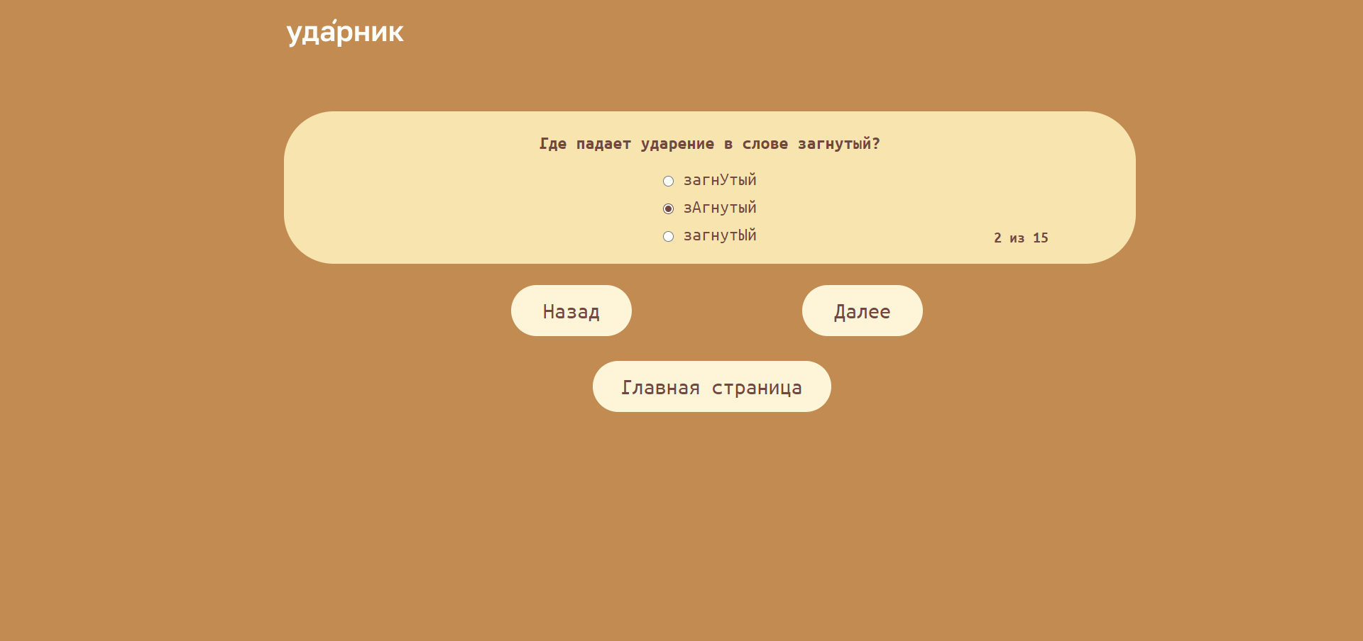

Рисунок 4 – Страница с викториной первого уровня

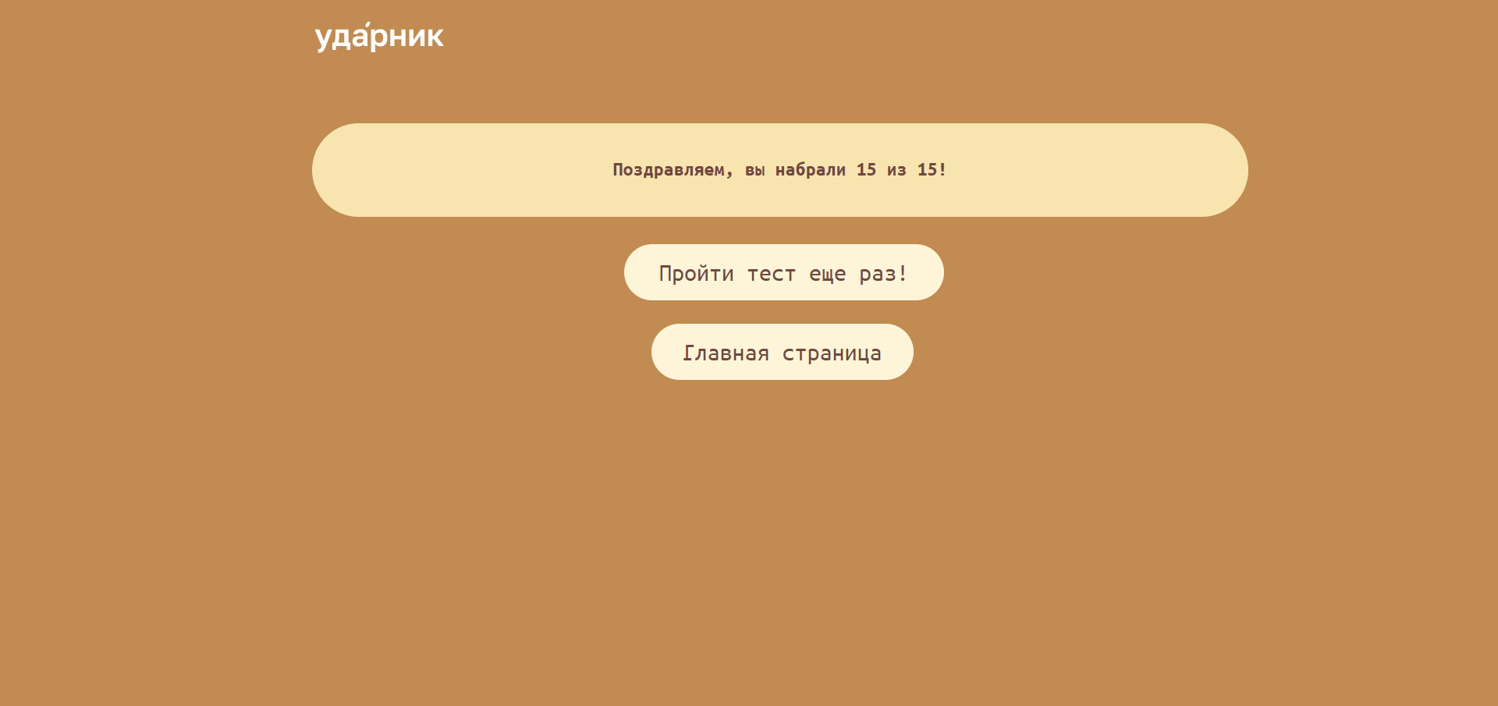

Рисунок 5 – Страница с результатами тестирования

В результате удалось разработать веб-приложение, со встроенными тестами для проверки уровня орфоэпической грамотности.

**Вывод:** в ходе выполнения практической работы удалось разработать веб-приложение в среде WordPress со встроенными тестами для определения орфоэпической грамотности.

Во время выполнения работы приходилось сталкиваться со множеством трудностей. Приходилось изучать множество документации и материалов, связанных с созданием веб-приложения, для того, чтобы добиться желаемого результата.

На рисунке 6 представлена доска проекта в Kaiten.

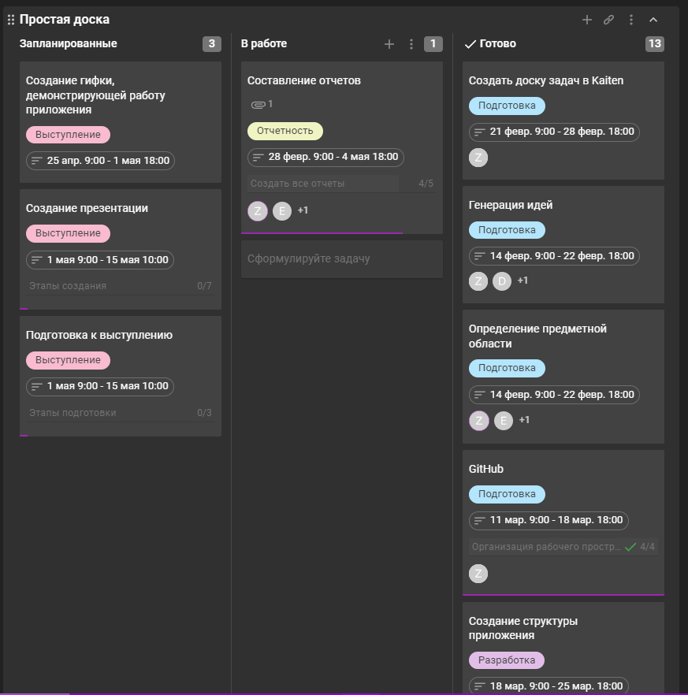

Рисунок 6 – Доска проекта в Kaiten

На рисунке 7 представлен скриншот с GitHub.

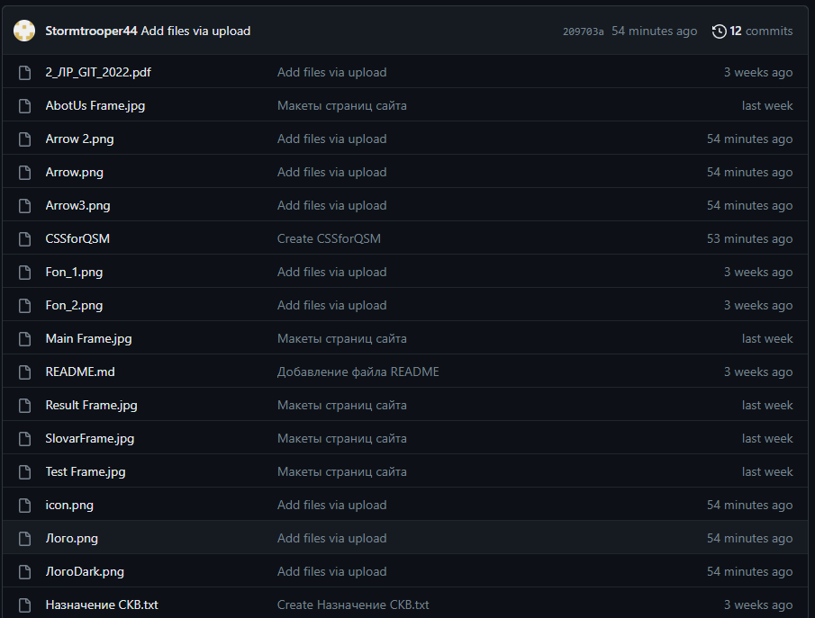

Рисунок 7 – Страница проекта на GitHub

**СПИСОК ИСПОЛЬЗОВАННЫХ ИСТОЧНИКОВ**

1 Figma, URL: [https://www.figma.com/](https://www.figma.com/%20) (дата обращения 04.04.2023).

2 WordPress, URL: [https://ru.wordpress.org/](https://ru.wordpress.org/%20) (дата обращения 04.04.2023).

3 Плагины WordPress, URL: [https://ru.wordpress.org/plugins/quiz-master-next/](https://ru.wordpress.org/plugins/quiz-master-next/%20) (дата обращения 04.04.2023).

4 QSM Documentation, URL: [https://quizandsurveymaster.com/docs/](https://quizandsurveymaster.com/docs/%20) (дата обращения 04.04.2023).

5 Основы CSS, URL: [https://developer.mozilla.org/ru/docs/Learn/Getting_started_with_the_web/CSS_basics](https://developer.mozilla.org/ru/docs/Learn/Getting_started_with_the_web/CSS_basics%20) (дата обращения 04.04.2023).

**ПРИЛОЖЕНИЯ**

**Приложение А. Фрагмент кода главной страницы**

|  |
| --- |
| <body class="home page-template page-template-elementor_canvas page page-id-20 logged-in admin-bar ehf-template-hello-elementor ehf-stylesheet-hello-elementor elementor-default elementor-template-canvas elementor-kit-6 elementor-page elementor-page-20 customize-support dialog-body dialog-buttons-body dialog-container dialog-buttons-container e--ua-blink e--ua-chrome e--ua-webkit" data-elementor-device-mode="desktop"> **//Базовые настройки Word Press**  <script>  (function() {  var request, b = document.body, c = 'className', cs = 'customize-support', rcs = new RegExp('(^|\\s+)(no-)?'+cs+'(\\s+|$)');  request = true;    b[c] = b[c].replace( rcs, ' ' );  // The customizer requires postMessage and CORS (if the site is cross domain).  b[c] += ( window.postMessage && request ? ' ' : ' no-' ) + cs;  }());  </script>  <div id="wpadminbar" class="nojq">  <div class="quicklinks" id="wp-toolbar" role="navigation" aria-label="Верхняя панель"> **// Информация о WordPress**  <ul id="wp-admin-bar-root-default" class="ab-top-menu"><li id="wp-admin-bar-wp-logo" class="menupop"><a class="ab-item" aria-haspopup="true" href="http://localhost/udarnik/wp-admin/about.php"><span class="ab-icon" aria-hidden="true"></span><span class="screen-reader-text">О WordPress</span></a><div class="ab-sub-wrapper"><ul id="wp-admin-bar-wp-logo-default" class="ab-submenu"><li id="wp-admin-bar-about"><a class="ab-item" href="http://localhost/udarnik/wp-admin/about.php">О WordPress</a></li></ul><ul id="wp-admin-bar-wp-logo-external" class="ab-sub-secondary ab-submenu"><li id="wp-admin-bar-wporg"><a class="ab-item" href="https://ru.wordpress.org/">WordPress.org</a></li><li id="wp-admin-bar-documentation"><a class="ab-item" href="https://wordpress.org/documentation/">Документация</a></li><li id="wp-admin-bar-support-forums"><a class="ab-item" href="https://ru.wordpress.org/support/forums/">Поддержка</a></li><li id="wp-admin-bar-feedback"><a class="ab-item" href="https://ru.wordpress.org/support/forum/requests-and-feedback/">Обратная связь</a></li></ul></div></li><li id="wp-admin-bar-site-name" class="menupop"><a class="ab-item" aria-haspopup="true" href="http://localhost/udarnik/wp-admin/">udarnik</a><div class="ab-sub-wrapper"><ul id="wp-admin-bar-site-name-default" class="ab-submenu"><li id="wp-admin-bar-dashboard"><a class="ab-item" href="http://localhost/udarnik/wp-admin/">Консоль</a></li></ul><ul id="wp-admin-bar-appearance" class="ab-submenu"><li id="wp-admin-bar-themes"><a class="ab-item" href="http://localhost/udarnik/wp-admin/themes.php">Темы</a></li><li id="wp-admin-bar-menus"><a class="ab-item" href="http://localhost/udarnik/wp-admin/nav-menus.php">Меню</a></li></ul></div></li><li id="wp-admin-bar-customize" class="hide-if-no-customize"><a class="ab-item" href="http://localhost/udarnik/wp-admin/customize.php?url=http%3A%2F%2Flocalhost%2Fudarnik%2F">Настроить</a></li><li id="wp-admin-bar-comments"><a class="ab-item" href="http://localhost/udarnik/wp-admin/edit-comments.php"><span class="ab-icon" aria-hidden="true"></span><span class="ab-label awaiting-mod pending-count count-0" aria-hidden="true">0</span><span class="screen-reader-text comments-in-moderation-text">0 комментариев ждут одобрения</span></a></li><li id="wp-admin-bar-new-content" class="menupop"><a class="ab-item" aria-haspopup="true" href="http://localhost/udarnik/wp-admin/post-new.php"><span class="ab-icon" aria-hidden="true"></span><span class="ab-label">Добавить</span></a><div class="ab-sub-wrapper"><ul id="wp-admin-bar-new-content-default" class="ab-submenu"><li id="wp-admin-bar-new-post"><a class="ab-item" href="http://localhost/udarnik/wp-admin/post-new.php">Запись</a></li><li id="wp-admin-bar-new-media"><a class="ab-item" href="http://localhost/udarnik/wp-admin/media-new.php">Медиафайл</a></li><li id="wp-admin-bar-new-page"><a class="ab-item" href="http://localhost/udarnik/wp-admin/post-new.php?post_type=page">Страницу</a></li><li id="wp-admin-bar-new-e-landing-page"><a class="ab-item" href="http://localhost/udarnik/wp-admin/edit.php?action=elementor_new_post&amp;post_type=e-landing-page&amp;template_type=landing-page&amp;_wpnonce=5f95ad6dde#library">Лендинг</a></li><li id="wp-admin-bar-new-elementor_library"><a class="ab-item" href="http://localhost/udarnik/wp-admin/post-new.php?post_type=elementor_library">Шаблон</a></li><li id="wp-admin-bar-new-qsm_quiz"><a class="ab-item" href="http://localhost/udarnik/wp-admin/post-new.php?post_type=qsm_quiz">Тест</a></li><li id="wp-admin-bar-new-user"><a class="ab-item" href="http://localhost/udarnik/wp-admin/user-new.php">Пользователя</a></li></ul></div></li><li id="wp-admin-bar-edit" class="menupop"><a class="ab-item" aria-haspopup="true" href="http://localhost/udarnik/wp-admin/post.php?post=20&amp;action=edit">Редактировать страницу</a><div class="ab-sub-wrapper"><ul id="wp-admin-bar-edit-default" class="ab-submenu"><li id="wp-admin-bar-duplicate_this"><a class="ab-item" href="http://localhost/udarnik/wp-admin/admin.php?action=dt_duplicate_post_as_draft&amp;post=20&amp;nonce=3cb611f0a0">Дублировать как draft</a></li></ul></div></li><li id="wp-admin-bar-elementor_edit_page" class="menupop"><a aria-haspopup="true" class="ab-item " href="http://localhost/udarnik/wp-admin/post.php?post=20&amp;action=elementor"><span class="elementor-edit-link-title">Редактировать в Elementor</span></a><div class="ab-sub-wrapper"><ul class="ab-submenu" id="wp-admin-bar-elementor_edit_page-default"><li id="wp-admin-bar-elementor_site_settings" class="elementor-second-section"><a class="ab-item elementor-site-settings" href="http://localhost/udarnik/wp-admin/post.php?post=20&amp;action=elementor#e:run:panel/global/open"><span class="elementor-edit-link-title">Настройки сайта</span><span class="elementor-edit-link-type">Сайт</span></a></li><li id="wp-admin-bar-elementor_app_site_editor" class="elementor-second-section"><a class="ab-item elementor-app-link" href="http://localhost/udarnik/wp-admin/admin.php?page=elementor-app&amp;ver=3.12.1#site-editor/promotion"><span class="elementor-edit-link-title">Конструктор тем</span><span class="elementor-edit-link-type">Сайт</span></a></li></ul></div></li></ul><ul id="wp-admin-bar-top-secondary" class="ab-top-secondary ab-top-menu"><li id="wp-admin-bar-search" class="admin-bar-search"><div class="ab-item ab-empty-item" tabindex="-1"><form action="http://localhost/udarnik/" method="get" id="adminbarsearch"><input class="adminbar-input" name="s" id="adminbar-search" type="text" value="" maxlength="150"><label for="adminbar-search" class="screen-reader-text">Поиск</label><input type="submit" class="adminbar-button" value="Поиск"></form></div></li><li id="wp-admin-bar-my-account" class="menupop with-avatar"><a class="ab-item" aria-haspopup="true" href="http://localhost/udarnik/wp-admin/profile.php">Привет, <span class="display-name">root</span><img alt="" src="http://0.gravatar.com/avatar/94a9d2ff38bb917831618626b01a611c?s=26&amp;d=mm&amp;r=g" srcset="http://0.gravatar.com/avatar/94a9d2ff38bb917831618626b01a611c?s=52&amp;d=mm&amp;r=g 2x" class="avatar avatar-26 photo" height="26" width="26" loading="lazy" decoding="async"></a><div class="ab-sub-wrapper"><ul id="wp-admin-bar-user-actions" class="ab-submenu"><li id="wp-admin-bar-user-info"><a class="ab-item" tabindex="-1" href="http://localhost/udarnik/wp-admin/profile.php"><img alt="" src="http://0.gravatar.com/avatar/94a9d2ff38bb917831618626b01a611c?s=64&amp;d=mm&amp;r=g" srcset="http://0.gravatar.com/avatar/94a9d2ff38bb917831618626b01a611c?s=128&amp;d=mm&amp;r=g 2x" class="avatar avatar-64 photo" height="64" width="64" loading="lazy" decoding="async"><span class="display-name">root</span></a></li><li id="wp-admin-bar-edit-profile"><a class="ab-item" href="http://localhost/udarnik/wp-admin/profile.php">Изменить профиль</a></li><li id="wp-admin-bar-logout"><a class="ab-item" href="http://localhost/udarnik/wp-login.php?action=logout&amp;_wpnonce=4de3b485e8">Выйти</a></li></ul></div></li></ul> </div>  <a class="screen-reader-shortcut" href="http://localhost/udarnik/wp-login.php?action=logout&amp;_wpnonce=4de3b485e8">Выйти</a>  </div>  <svg xmlns="http://www.w3.org/2000/svg" viewBox="0 0 0 0" width="0" height="0" focusable="false" role="none" style="visibility: hidden; position: absolute; left: -9999px; overflow: hidden;"><defs><filter id="wp-duotone-dark-grayscale"><feColorMatrix color-interpolation-filters="sRGB" type="matrix" values=" .299 .587 .114 0 0 .299 .587 .114 0 0 .299 .587 .114 0 0 .299 .587 .114 0 0 "></feColorMatrix><feComponentTransfer color-interpolation-filters="sRGB"><feFuncR type="table" tableValues="0 0.49803921568627"></feFuncR><feFuncG type="table" tableValues="0 0.49803921568627"></feFuncG><feFuncB type="table" tableValues="0 0.49803921568627"></feFuncB><feFuncA type="table" tableValues="1 1"></feFuncA></feComponentTransfer><feComposite in2="SourceGraphic" operator="in"></feComposite></filter></defs></svg><svg xmlns="http://www.w3.org/2000/svg" viewBox="0 0 0 0" width="0" height="0" focusable="false" role="none" style="visibility: hidden; position: absolute; left: -9999px; overflow: hidden;"><defs><filter id="wp-duotone-grayscale"><feColorMatrix color-interpolation-filters="sRGB" type="matrix" values=" .299 .587 .114 0 0 .299 .587 .114 0 0 .299 .587 .114 0 0 .299 .587 .114 0 0 "></feColorMatrix><feComponentTransfer color-interpolation-filters="sRGB"><feFuncR type="table" tableValues="0 1"></feFuncR><feFuncG type="table" tableValues="0 1"></feFuncG><feFuncB type="table" tableValues="0 1"></feFuncB><feFuncA type="table" tableValues="1 1"></feFuncA></feComponentTransfer><feComposite in2="SourceGraphic" operator="in"></feComposite></filter></defs></svg><svg xmlns="http://www.w3.org/2000/svg" viewBox="0 0 0 0" width="0" height="0" focusable="false" role="none" style="visibility: hidden; position: absolute; left: -9999px; overflow: hidden;"><defs><filter id="wp-duotone-purple-yellow"><feColorMatrix color-interpolation-filters="sRGB" type="matrix" values=" .299 .587 .114 0 0 .299 .587 .114 0 0 .299 .587 .114 0 0 .299 .587 .114 0 0 "></feColorMatrix><feComponentTransfer color-interpolation-filters="sRGB"><feFuncR type="table" tableValues="0.54901960784314 0.98823529411765"></feFuncR><feFuncG type="table" tableValues="0 1"></feFuncG><feFuncB type="table" tableValues="0.71764705882353 0.25490196078431"></feFuncB><feFuncA type="table" tableValues="1 1"></feFuncA></feComponentTransfer><feComposite in2="SourceGraphic" operator="in"></feComposite></filter></defs></svg><svg xmlns="http://www.w3.org/2000/svg" viewBox="0 0 0 0" width="0" height="0" focusable="false" role="none" style="visibility: hidden; position: absolute; left: -9999px; overflow: hidden;"><defs><filter id="wp-duotone-blue-red"><feColorMatrix color-interpolation-filters="sRGB" type="matrix" values=" .299 .587 .114 0 0 .299 .587 .114 0 0 .299 .587 .114 0 0 .299 .587 .114 0 0 "></feColorMatrix><feComponentTransfer color-interpolation-filters="sRGB"><feFuncR type="table" tableValues="0 1"></feFuncR><feFuncG type="table" tableValues="0 0.27843137254902"></feFuncG><feFuncB type="table" tableValues="0.5921568627451 0.27843137254902"></feFuncB><feFuncA type="table" tableValues="1 1"></feFuncA></feComponentTransfer><feComposite in2="SourceGraphic" operator="in"></feComposite></filter></defs></svg><svg xmlns="http://www.w3.org/2000/svg" viewBox="0 0 0 0" width="0" height="0" focusable="false" role="none" style="visibility: hidden; position: absolute; left: -9999px; overflow: hidden;"><defs><filter id="wp-duotone-midnight"><feColorMatrix color-interpolation-filters="sRGB" type="matrix" values=" .299 .587 .114 0 0 .299 .587 .114 0 0 .299 .587 .114 0 0 .299 .587 .114 0 0 "></feColorMatrix><feComponentTransfer color-interpolation-filters="sRGB"><feFuncR type="table" tableValues="0 0"></feFuncR><feFuncG type="table" tableValues="0 0.64705882352941"></feFuncG><feFuncB type="table" tableValues="0 1"></feFuncB><feFuncA type="table" tableValues="1 1"></feFuncA></feComponentTransfer><feComposite in2="SourceGraphic" operator="in"></feComposite></filter></defs></svg><svg xmlns="http://www.w3.org/2000/svg" viewBox="0 0 0 0" width="0" height="0" focusable="false" role="none" style="visibility: hidden; position: absolute; left: -9999px; overflow: hidden;"><defs><filter id="wp-duotone-magenta-yellow"><feColorMatrix color-interpolation-filters="sRGB" type="matrix" values=" .299 .587 .114 0 0 .299 .587 .114 0 0 .299 .587 .114 0 0 .299 .587 .114 0 0 "></feColorMatrix><feComponentTransfer color-interpolation-filters="sRGB"><feFuncR type="table" tableValues="0.78039215686275 1"></feFuncR><feFuncG type="table" tableValues="0 0.94901960784314"></feFuncG><feFuncB type="table" tableValues="0.35294117647059 0.47058823529412"></feFuncB><feFuncA type="table" tableValues="1 1"></feFuncA></feComponentTransfer><feComposite in2="SourceGraphic" operator="in"></feComposite></filter></defs></svg><svg xmlns="http://www.w3.org/2000/svg" viewBox="0 0 0 0" width="0" height="0" focusable="false" role="none" style="visibility: hidden; position: absolute; left: -9999px; overflow: hidden;"><defs><filter id="wp-duotone-purple-green"><feColorMatrix color-interpolation-filters="sRGB" type="matrix" values=" .299 .587 .114 0 0 .299 .587 .114 0 0 .299 .587 .114 0 0 .299 .587 .114 0 0 "></feColorMatrix><feComponentTransfer color-interpolation-filters="sRGB"><feFuncR type="table" tableValues="0.65098039215686 0.40392156862745"></feFuncR><feFuncG type="table" tableValues="0 1"></feFuncG><feFuncB type="table" tableValues="0.44705882352941 0.4"></feFuncB><feFuncA type="table" tableValues="1 1"></feFuncA></feComponentTransfer><feComposite in2="SourceGraphic" operator="in"></feComposite></filter></defs></svg><svg xmlns="http://www.w3.org/2000/svg" viewBox="0 0 0 0" width="0" height="0" focusable="false" role="none" style="visibility: hidden; position: absolute; left: -9999px; overflow: hidden;"><defs><filter id="wp-duotone-blue-orange"><feColorMatrix color-interpolation-filters="sRGB" type="matrix" values=" .299 .587 .114 0 0 .299 .587 .114 0 0 .299 .587 .114 0 0 .299 .587 .114 0 0 "></feColorMatrix><feComponentTransfer color-interpolation-filters="sRGB"><feFuncR type="table" tableValues="0.098039215686275 1"></feFuncR><feFuncG type="table" tableValues="0 0.66274509803922"></feFuncG><feFuncB type="table" tableValues="0.84705882352941 0.41960784313725"></feFuncB><feFuncA type="table" tableValues="1 1"></feFuncA></feComponentTransfer><feComposite in2="SourceGraphic" operator="in"></feComposite></filter></defs></svg> <div data-elementor-type="wp-page" data-elementor-id="20" class="elementor elementor-20">  <section class="elementor-section elementor-top-section elementor-element elementor-element-6cce510 elementor-section-boxed elementor-section-height-default elementor-section-height-default" data-id="6cce510" data-element_type="section">  <div class="elementor-container elementor-column-gap-default">  <div class="elementor-column elementor-col-20 elementor-top-column elementor-element elementor-element-50f67c7" data-id="50f67c7" data-element_type="column" data-settings="{&quot;animation&quot;:&quot;none&quot;}">  <div class="elementor-widget-wrap elementor-element-populated">  <div class="elementor-element elementor-element-1ca186f scale-parent elementor-widget elementor-widget-image" data-id="1ca186f" data-element_type="widget" data-widget_type="image.default">  <div class="elementor-widget-container">  <style>/*! elementor - v3.12.1 - 02-04-2023 */  .elementor-widget-image{text-align:center}.elementor-widget-image a{display:inline-block}.elementor-widget-image a img[src$=".svg"]{width:48px}.elementor-widget-image img{vertical-align:middle;display:inline-block}</style> <a href="http://localhost/udarnik/">  <img decoding="async" width="167" height="48" src="http://localhost/udarnik/wp-content/uploads/2023/03/Лого.png" class="attachment-full size-full wp-image-28" alt="" loading="lazy"> </a>  **// создание ссылки на раздел о нас** </div>  </div>  </div>  </div>  <div class="elementor-column elementor-col-20 elementor-top-column elementor-element elementor-element-4914e8b" data-id="4914e8b" data-element_type="column">  <div class="elementor-widget-wrap">  </div>  </div>  <div class="elementor-column elementor-col-20 elementor-top-column elementor-element elementor-element-a497277" data-id="a497277" data-element_type="column">  <div class="elementor-widget-wrap">  </div>  </div>  <div class="elementor-column elementor-col-20 elementor-top-column elementor-element elementor-element-68b6793" data-id="68b6793" data-element_type="column">  <div class="elementor-widget-wrap elementor-element-populated">  <div class="elementor-element elementor-element-f15ddfd elementor-widget elementor-widget-heading" data-id="f15ddfd" data-element_type="widget" data-widget_type="heading.default">  <div class="elementor-widget-container">  <style>/*! elementor - v3.12.1 - 02-04-2023 */  .elementor-heading-title{padding:0;margin:0;line-height:1}.elementor-widget-heading .elementor-heading-title[class*=elementor-size-]>a{color:inherit;font-size:inherit;line-height:inherit}.elementor-widget-heading .elementor-heading-title.elementor-size-small{font-size:15px}.elementor-widget-heading .elementor-heading-title.elementor-size-medium{font-size:19px}.elementor-widget-heading .elementor-heading-title.elementor-size-large{font-size:29px}.elementor-widget-heading .elementor-heading-title.elementor-size-xl{font-size:39px}.elementor-widget-heading .elementor-heading-title.elementor-size-xxl{font-size:59px}</style><h2 class="elementor-heading-title elementor-size-default"><a href="http://localhost/udarnik/about-us/">о нас</a></h2> </div>  </div>  </div>  </div> **//создание ссылки на страницу со словарем**  <div class="elementor-column elementor-col-20 elementor-top-column elementor-element elementor-element-64eb3b3" data-id="64eb3b3" data-element_type="column">  <div class="elementor-widget-wrap elementor-element-populated">  <div class="elementor-element elementor-element-a8a2f5f elementor-widget elementor-widget-heading" data-id="a8a2f5f" data-element_type="widget" data-widget_type="heading.default">  <div class="elementor-widget-container">  <h2 class="elementor-heading-title elementor-size-default"><a href="http://localhost/udarnik/dictionary/">словарь с ударениями</a></h2> </div>  </div>  </div>  </div>  </div>  </section>  <section class="elementor-section elementor-top-section elementor-element elementor-element-173b358 elementor-section-boxed elementor-section-height-default elementor-section-height-default" data-id="173b358" data-element_type="section">  <div class="elementor-container elementor-column-gap-default">  <div class="elementor-column elementor-col-100 elementor-top-column elementor-element elementor-element-82259a3" data-id="82259a3" data-element_type="column">  <div class="elementor-widget-wrap elementor-element-populated">  <div class="elementor-element elementor-element-8ec8e62 elementor-widget elementor-widget-spacer" data-id="8ec8e62" data-element_type="widget" data-widget_type="spacer.default">  <div class="elementor-widget-container">  <style>/*! elementor - v3.12.1 - 02-04-2023 */  .elementor-column .elementor-spacer-inner{height:var(--spacer-size)}.e-con{--container-widget-width:100%}.e-con-inner>.elementor-widget-spacer,.e-con>.elementor-widget-spacer{width:var(--container-widget-width,var(--spacer-size));--align-self:var(--container-widget-align-self,initial);--flex-shrink:0}.e-con-inner>.elementor-widget-spacer>.elementor-widget-container,.e-con-inner>.elementor-widget-spacer>.elementor-widget-container>.elementor-spacer,.e-con>.elementor-widget-spacer>.elementor-widget-container,.e-con>.elementor-widget-spacer>.elementor-widget-container>.elementor-spacer{height:100%}.e-con-inner>.elementor-widget-spacer>.elementor-widget-container>.elementor-spacer>.elementor-spacer-inner,.e-con>.elementor-widget-spacer>.elementor-widget-container>.elementor-spacer>.elementor-spacer-inner{height:var(--container-widget-height,var(--spacer-size))}</style> <div class="elementor-spacer">  <div class="elementor-spacer-inner"></div>  </div>  </div>  </div>  </div>  </div>  </div>  </section>  <section class="elementor-section elementor-top-section elementor-element elementor-element-c6ebf40 elementor-section-boxed elementor-section-height-default elementor-section-height-default" data-id="c6ebf40" data-element_type="section">  <div class="elementor-container elementor-column-gap-default">  <div class="elementor-column elementor-col-100 elementor-top-column elementor-element elementor-element-5fd3f92" data-id="5fd3f92" data-element_type="column" data-settings="{&quot;background_background&quot;:&quot;classic&quot;}">  <div class="elementor-widget-wrap elementor-element-populated">  <div class="elementor-element elementor-element-0aa7ef0 elementor-widget__width-initial elementor-widget elementor-widget-text-editor" data-id="0aa7ef0" data-element_type="widget" data-widget_type="text-editor.default">  <div class="elementor-widget-container">  <style>/*! elementor - v3.12.1 - 02-04-2023 */  .elementor-widget-text-editor.elementor-drop-cap-view-stacked .elementor-drop-cap{background-color:#69727d;color:#fff}.elementor-widget-text-editor.elementor-drop-cap-view-framed .elementor-drop-cap{color:#69727d;border:3px solid;background-color:transparent}.elementor-widget-text-editor:not(.elementor-drop-cap-view-default) .elementor-drop-cap{margin-top:8px}.elementor-widget-text-editor:not(.elementor-drop-cap-view-default) .elementor-drop-cap-letter{width:1em;height:1em}.elementor-widget-text-editor .elementor-drop-cap{float:left;text-align:center;line-height:1;font-size:50px}.elementor-widget-text-editor .elementor-drop-cap-letter{display:inline-block}</style> **//Создание вводной информации о сайте**  <p><span style="white-space: pre-wrap;">Добро пожаловать на сайт по проверке правильности постановки ударений! <br>Предлагаем Вам протестировать себя на уровень знаний орфоэпии русского языка! <br></span></p> </div>  </div>  </div>  </div>  </div>  </section>  <section class="elementor-section elementor-top-section elementor-element elementor-element-992a721 elementor-section-boxed elementor-section-height-default elementor-section-height-default" data-id="992a721" data-element_type="section">  <div class="elementor-container elementor-column-gap-default">  <div class="elementor-column elementor-col-100 elementor-top-column elementor-element elementor-element-2a52e60" data-id="2a52e60" data-element_type="column">  <div class="elementor-widget-wrap elementor-element-populated">  <div class="elementor-element elementor-element-8bff562 elementor-widget elementor-widget-spacer" data-id="8bff562" data-element_type="widget" data-widget_type="spacer.default">  <div class="elementor-widget-container">  <div class="elementor-spacer">  <div class="elementor-spacer-inner"></div>  </div>  </div>  </div>  </div>  </div>  </div>  </section>  <section class="elementor-section elementor-top-section elementor-element elementor-element-b83d7a2 elementor-section-boxed elementor-section-height-default elementor-section-height-default" data-id="b83d7a2" data-element_type="section">  <div class="elementor-container elementor-column-gap-default">  <div class="elementor-column elementor-col-100 elementor-top-column elementor-element elementor-element-73592df" data-id="73592df" data-element_type="column">  <div class="elementor-widget-wrap elementor-element-populated">  <div class="elementor-element elementor-element-43dea9f elementor-align-center elementor-widget elementor-widget-button" data-id="43dea9f" data-element_type="widget" data-widget_type="button.default"> // создание кнопки 1 уровень  <div class="elementor-widget-container">  <div class="elementor-button-wrapper">  <a href="http://localhost/udarnik/test/" class="elementor-button-link elementor-button elementor-size-sm elementor-animation-grow" role="button">  <span class="elementor-button-content-wrapper">  <span class="elementor-button-text">1 уровень</span>  </span>  </a>  </div>  </div>  </div> /**/создание кнопки 2 уровень**  <div class="elementor-element elementor-element-4849136 elementor-align-center elementor-widget elementor-widget-button" data-id="4849136" data-element_type="widget" data-widget_type="button.default">  <div class="elementor-widget-container">  <div class="elementor-button-wrapper">  <a href="http://localhost/udarnik/test2/" class="elementor-button-link elementor-button elementor-size-sm elementor-animation-grow" role="button">  <span class="elementor-button-content-wrapper">  <span class="elementor-button-text">2 уровень</span>  </span>  </a>  </div>  </div>  </div> **//Создание кнопки 3 уровень**  <div class="elementor-element elementor-element-c616756 elementor-align-center elementor-widget elementor-widget-button" data-id="c616756" data-element_type="widget" data-widget_type="button.default">  <div class="elementor-widget-container">  <div class="elementor-button-wrapper">  <a href="http://localhost/udarnik/test3/" class="elementor-button-link elementor-button elementor-size-sm elementor-animation-grow" role="button">  <span class="elementor-button-content-wrapper">  <span class="elementor-button-text">3 уровень</span>  </span>  </a>  </div>  </div>  </div>  </div>  </div>  </div>  </section>  <section class="elementor-section elementor-top-section elementor-element elementor-element-c16357d elementor-section-boxed elementor-section-height-default elementor-section-height-default" data-id="c16357d" data-element_type="section">  <div class="elementor-container elementor-column-gap-default">  <div class="elementor-column elementor-col-33 elementor-top-column elementor-element elementor-element-7d6892b" data-id="7d6892b" data-element_type="column">  <div class="elementor-widget-wrap elementor-element-populated">  <div class="elementor-element elementor-element-1d1e4e9 elementor-widget elementor-widget-heading" data-id="1d1e4e9" data-element_type="widget" data-widget_type="heading.default">  <div class="elementor-widget-container"> **//Создание раздела с интересным фактом**  <h2 class="elementor-heading-title elementor-size-default">Интересный факт:</h2> </div>  </div>  </div>  </div>  <div class="elementor-column elementor-col-33 elementor-top-column elementor-element elementor-element-a2fb2d4" data-id="a2fb2d4" data-element_type="column">  <div class="elementor-widget-wrap">  </div>  </div>  <div class="elementor-column elementor-col-33 elementor-top-column elementor-element elementor-element-f34304f" data-id="f34304f" data-element_type="column">  <div class="elementor-widget-wrap">  </div>  </div>  </div>  </section>  <section class="elementor-section elementor-top-section elementor-element elementor-element-d221785 elementor-section-boxed elementor-section-height-default elementor-section-height-default" data-id="d221785" data-element_type="section">  <div class="elementor-container elementor-column-gap-default">  <div class="elementor-column elementor-col-100 elementor-top-column elementor-element elementor-element-72ba3c8" data-id="72ba3c8" data-element_type="column" data-settings="{&quot;background_background&quot;:&quot;classic&quot;}">  <div class="elementor-widget-wrap elementor-element-populated">  <div class="elementor-element elementor-element-2905b23 elementor-widget elementor-widget-text-editor" data-id="2905b23" data-element_type="widget" data-widget_type="text-editor.default">  <div class="elementor-widget-container">  <p><span style="white-space: pre-wrap;">В русском, английском, французском, польском и ряде других языков ударение ставится силой выдоха. А вот в литовском, китайском, японском и др. языках – изменением высоты голосового тона. В некоторых языках наблюдается комбинация этих средств.</span></p> </div>  </div>  </div>  </div>  </div>  </section>  <section class="elementor-section elementor-top-section elementor-element elementor-element-c1cdeeb elementor-section-boxed elementor-section-height-default elementor-section-height-default" data-id="c1cdeeb" data-element_type="section">  <div class="elementor-container elementor-column-gap-default">  <div class="elementor-column elementor-col-100 elementor-top-column elementor-element elementor-element-5c42b7c" data-id="5c42b7c" data-element_type="column">  <div class="elementor-widget-wrap elementor-element-populated">  <div class="elementor-element elementor-element-8ba1641 elementor-widget elementor-widget-spacer" data-id="8ba1641" data-element_type="widget" data-widget_type="spacer.default">  <div class="elementor-widget-container">  <div class="elementor-spacer">  <div class="elementor-spacer-inner"></div>  </div>  </div>  </div>  </div>  </div>  </div>  </section> **//Добавление футера**  <section class="elementor-section elementor-top-section elementor-element elementor-element-cecdbc1 elementor-section-boxed elementor-section-height-default elementor-section-height-default" data-id="cecdbc1" data-element_type="section">  <div class="elementor-container elementor-column-gap-default">  <div class="elementor-column elementor-col-100 elementor-top-column elementor-element elementor-element-13b9c2a" data-id="13b9c2a" data-element_type="column">  <div class="elementor-widget-wrap elementor-element-populated">  <div class="elementor-element elementor-element-0ea5557 elementor-widget elementor-widget-text-editor" data-id="0ea5557" data-element_type="widget" data-widget_type="text-editor.default">  <div class="elementor-widget-container">  <p>Ударник. ГУАП СПб 2023.</p> </div>  </div>  </div>  </div>  </div>  </section>  </div>  <div id="wpfront-scroll-top-container" style="opacity: 0; right: 50px; bottom: 30px;">  <img src="http://localhost/udarnik/wp-content/uploads/2023/04/Arrow3.png" alt="" style="width: auto; height: auto;"> </div>  <script type="text/javascript">  function wpfront_scroll_top_init() {  if (typeof wpfront_scroll_top === "function" && typeof jQuery !== "undefined") |

**Приложение Б. CSS-код для плагина QSM**

|  |
| --- |
| .qsm-page { //Раздел с вопросами  color: #734740;  background-color: #F8E4AF;  border-radius: 70px;  font-size: 26px;  text-align: center;  width: 1200px;  height: 215px;  left: 40px;  top: 277px;  font-family: Ubuntu Mono;  padding: 25px 45px !important;  }  .qmn_quiz_radio { //Переключатель вопрсов  width: 15px;  height: 15px;  vertical-align: -4px;  }  .qmn_quiz_radio {  accent-color: #734740 !important ;  }  .qsm-results-page { //результаты тестирования  background-color: #F8E4AF;  border-radius: 70px;  font-size: 26px;  text-align: center;  width: 1200px;  height: 120px;  top: 277px;  font-family: Ubuntu Mono;  color: #734740;  }  .qmn_quiz_container .qmn_btn.mlw_next { //кнопка далее  background: #FEF5D8 !important;  color: #734740!important;  border-radius: 40px !important;  font-size: 32px !important;  font-family: Ubuntu Mono !important;  padding: 25px 45px !important;  top: 30px;  left: 730px;  outline: none !important;  box-shadow: none !important;  border: none !important;  }  .qmn_quiz_container .qmn_btn.mlw_next:hover {  background-color: #F8E4AF !important;  outline: none !important;  }  .qmn_quiz_container .qmn_btn.mlw_previous { //кнопка назад  background: #FEF5D8 !important;  color: #734740!important;  border-radius: 40px !important;  font-size: 32px !important;  font-family: Ubuntu Mono !important;  padding: 25px 45px !important;  position: absolute !important;  top: 245px;  left: 320px;  outline: none !important;  box-shadow: none !important;  border: none !important;  }  .qmn_quiz_container .qmn_btn.mlw_previous:hover {  background-color: #F8E4AF !important;  outline: none !important;  }  input.qsm-btn.qsm-submit-btn.qmn_btn { //кнопка закончить  background: #FEF5D8 !important;  color: #734740!important;  border-radius: 40px !important;  font-size: 32px !important;  font-family: Ubuntu Mono !important;  padding: 25px 45px !important;  top: 30px;  left: 720px;  outline: none !important;  box-shadow: none !important;  border: none !important;  }  input.qsm-btn.qsm-submit-btn.qmn_btn:active {  outline: none;  box-shadow: none;  }  input.qsm-btn.qsm-submit-btn.qmn_btn:focus {  outline: none;  box-shadow: none;  }  input.qsm-btn.qsm-submit-btn.qmn_btn:hover {  background-color: #F8E4AF !important;  outline: none !important;  }  input.qsm_retake_button { //кнопка пройти тест еще раз  background: #FEF5D8 !important;  color: #734740!important;  border-radius: 40px !important;  font-size: 32px !important;  font-family: Ubuntu Mono !important;  padding: 25px 45px !important;  top: 35px;  left: 400px;  outline: none !important;  box-shadow: none !important;  border: none !important;  }  input.qsm_retake_button:active {  outline: none;  box-shadow: none;  }  input.qsm_retake_button:focus {  outline: none;  box-shadow: none;  }  input.qsm_retake_button:hover {  background-color: #F8E4AF !important;  outline: none !important;  }  .pages_count, //номер страниц  .qsm-page .pages_count,  .quiz_section .pages_count {  font-size: 22px;  font-weight: 700;  font-family: Ubuntu Mono;  text-align: center;  top: 162px;  left: 1000px;  position: absolute !important;  } |